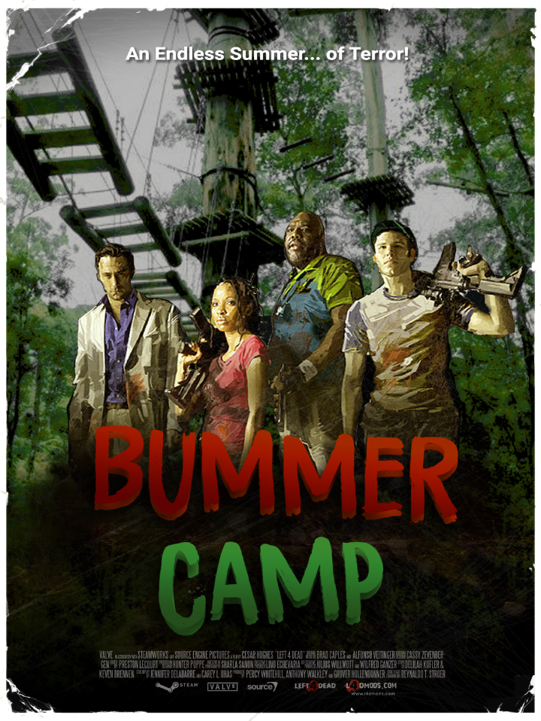
Figure 1: Level Cover Photo

Left 4 Dead: Bummer Camp
  - Version 2.0
Designer: | Austin Merritt
Document Date: | 4/28
Intended Level Delivery Date: | 4/29

Document Revisions Table
Version | Description | Requestor | Date
1.0 | Initial Document | Professor Stephens | 1/31
1.1 | Grammar Fixes, Special Infected Notes, Contact Sheet Grammar Fixes | Professor Stephens | 2/6
1.2 | Updated Maps to Match Whitebox Flow, Added New Keys For Each Map | Professor Stephens | 2/21
1.3 | - Updated All Maps with Jungle Gyms  - Updated All Maps with Starting Area Car Arrangement  - Updated Section 1 map with Additional Event Descriptions  - Updated Section 2 Map with Witch and Tank Spawns  - Updated Section 2 Map with Additional Event Descriptions  - Updated Section 2 Map with Optional Elevated Routes  - Updated Section 2 Map with Locations of Rescue Closets  - Updated Section 3 Map with Additional Spawn Treehouses  - Updated Section 3 Map with Locations of Rescue Closets | Professor Stephens | 3/12
1.4 | - Updated Asset list with Custom Asset List  - Added additional Description to Section 2 Map: Event 2 to reflect new scripting  - Added Healing Item in map for Section 2 | Professor Stephens | 4/3
1.5 | - Updated Section 2 Map with New items and interactibles  - Updated Section 2 Event Descriptions to Match Map Changes | Professor Stephens | 4/17
2.0 | - No Changes, Finalized | Professor Stephens | 4/28

Table of Contents
Table of Contents 3
Table of Figures 9
Level Information 10
Quick Summary 10
Level Map(s) 11
Bummer Camp Top Down Overview 11
Perspective Map Overview 13
Nav and Director Breakdown Map 14
Bummer Camp Section 1 Detailed Breakdown 16
Bummer Camp Section 2 Detailed Breakdown 18
Bummer Camp Section 3 Detailed Breakdown 20
Objective(s) 22
Hook(s)/Gameplay Highlights 22
Campaign Level 22
Context 22
Aftermath 22
Development Schedule 22
Key Theme References 23
Camp Entrance 23
Mess Hall 24
Lake 25
Cabin 26
Treetop Obstacle Course 27
Asset List 28
Custom Assets 31
References 32

Table of Figures
Figure 1: Level Cover Photo 1
Figure 2: Map Overview 6
Figure 3: Perspective Overview 8
Figure 4: Nav Overview 9
Figure 5: Section 1 Overview 11
Figure 6: Section 2 Overview 13
Figure 7: Section 3 Overview 15
Figure 8: Camp Entrance Contact Sheet 18
Figure 9: Mess Hall Contact Sheet 19
Figure 10: Lake Contact Sheet 20
Figure 11: Cabin Contact Sheet 21
Figure 12: Obstacle Course Contact Sheet 22

Level Design Document

Level Information

Quick Summary
In Bummer Camp survivors must make their way to a rescue boat by fighting through a dilapidated lakeside summer camp.
- In the first section of the level players navigate the outskirts of the summer camp with the weaker weapons within the game.
- In the second section of the level players are given stronger weapons and explore the mess hall, lake, and cabins.
- In the final section of the level players are given the strongest weapons to help face a never-ending onslaught as they navigate a treacherous tree-top obstacle course to safety.

Level Map(s)

Bummer Camp Top Down Overview

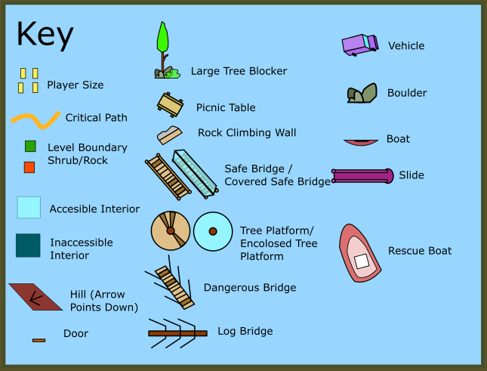
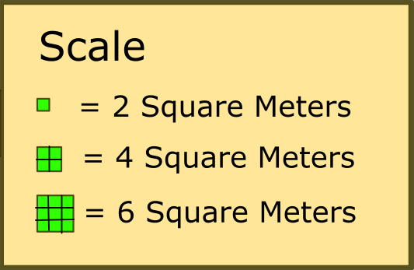
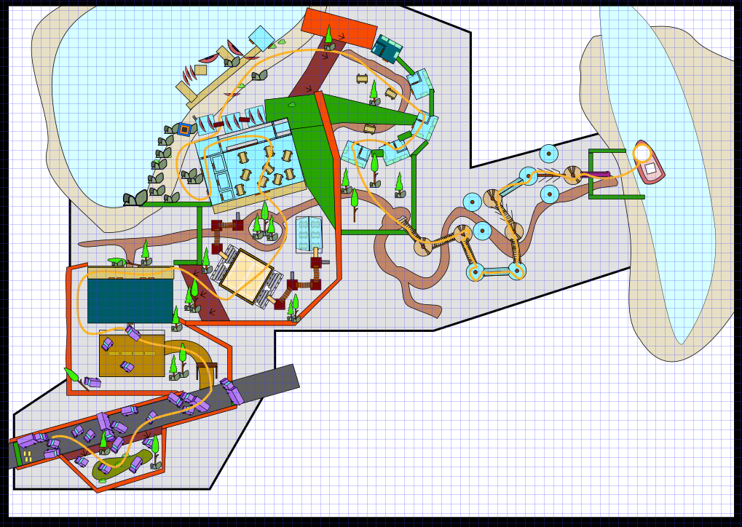
Tree Course
Cabins
Lakeside Docks
Welcome Building
Mess Hall
Volleyball
Player Start
Rescue
8
9
7
6
5
4
3
2
1
Figure 2: Map Overview
Map Label | Event Description | Detail Information | Approx. Difficulty (1-10) | Approx. Time
1 | Players Start Map | The survivors’ car has run out of gas and so the players must make their way to the coast on foot. Players begin by navigating a backwoods road full of abandoned cars with only melee weapons. | 1 | 0:00
2 | Players Enter Campgrounds | The players discover a ransacked and decimated summer camp serving as their only way forward. They head around the welcome building gathering new weapons along the way. | 2 | 2:00
3 | Players Fight Through Activity Area | Players fight through and navigate beach volleyball courts, gazebos, and jungle gyms as they head towards the large mess hall ahead of them | 3 | 4:00
4 | Players Hold Out in Mess Hall | Players fight off increasing hordes of the undead as they loudly raise a metal grate into the mess hall cafeteria | 5 | 6:00
5 | Players Move Along Shore | Following the mess hall players find themselves along the shore of the camp’s lake as they move around boulders and boats shooting zombies in their path | 4 | 8:00
6 | Players Scavenge Cabins | Moving away from the shore leads to a semi-circle of cabins filled with loot and the undead | 6 | 10:00
7 | Players Climb Rock Wall | Players head to the woods where they discover a rock wall as means of progression | 2 | 11:30
8 | Players Face Onslaught on Treetops | The camp’s loudspeakers are set off within the camp’s treetop obstacle course causes hordes of enemies to come toward the players | 8 | 13:00
9 | Players Use Slide and Escape on Boat | At the end of the obstacle course is a steep slide leading to the shore where a boat waits for the players to aid in their escape | 5 | 15:00

Perspective Map Overview

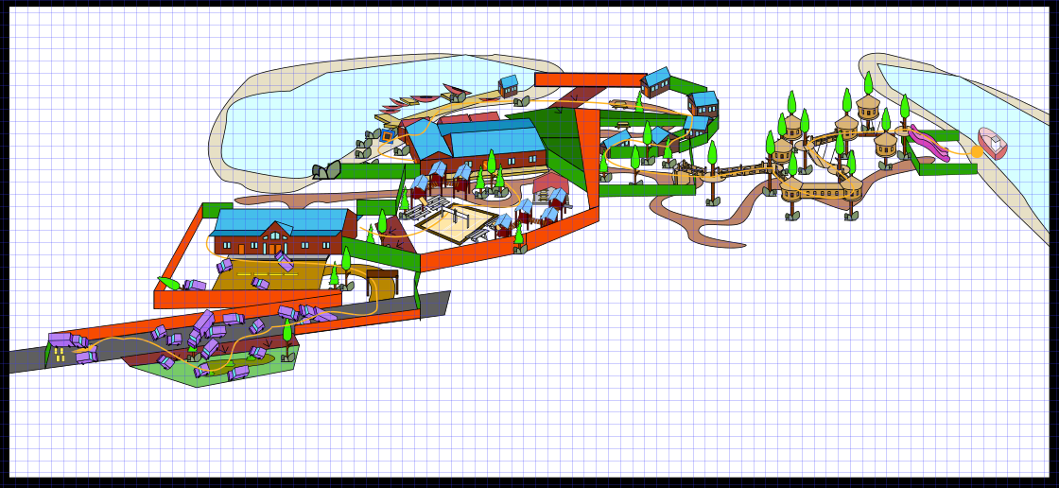
Rescue
Cabins
Volleyball
Tree Course
Mess Hall
Lakeside Docks
Welcome Building
Player Start
4
1 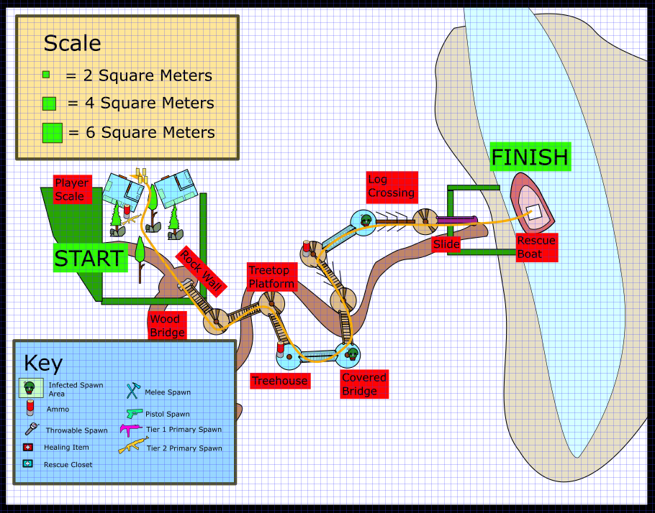
7
3
6
5
2
Figure 3: Perspective Overview

Map Label | Event Description | Detail Information
1 | Players Start Map | Players start on a flat highway broken up by cars and trucks of various sizes. Players start in a safe area that zombies cannot access. Players must jump over the cop car before the zombies will come after them.
2 | Players Navigate Through Swampy Foliage | With the main route blocked players head down a small hill to a lowered grassy and muddy area full of half submerged cars
3 | Players Circle Around Large Welcome Building | The large welcome building acts as a strong landmark for players to navigate around
4 | Players Head Up Hill to Volleyball Courts | Players head up a hill to find a volleyball net they can go under
5 | Players Head Down Hill to Cabin Site | After moving along the shore players move down a gentle slope to the camper cabins
6 | Players Climb into The Trees & Face Onslaught | Players climb a large rock wall enabling them to cross wooden bridges high above the forest floor
7 | Players Slide to Forest Floor for Escape | The slide carries the players from the elevated wooden pathways to the shore where the boat awaits.

Nav and Director Breakdown Map
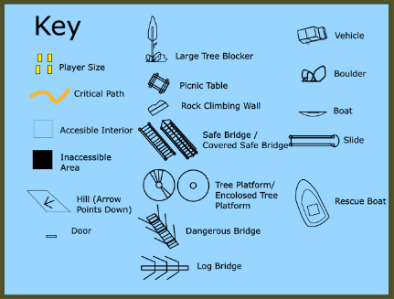
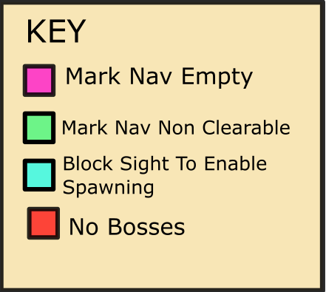
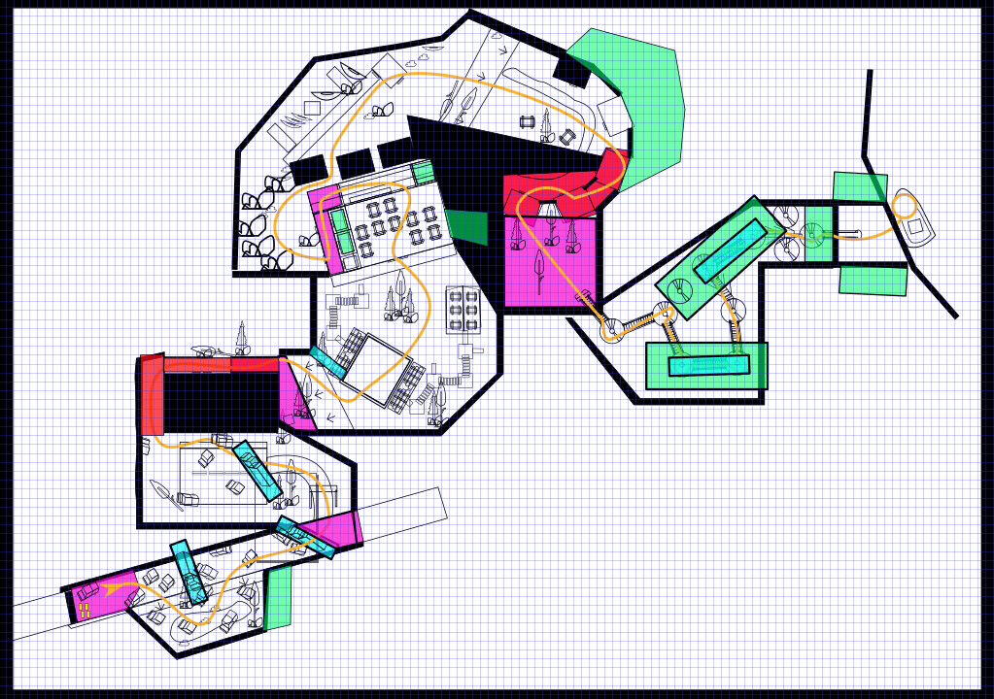
Lakeside Docks
Welcome Building
Rescue
Cabins
Mess Hall
Tree Course
Volleyball
Player Start
3
2
7
8
5
6
4
1
Figure 4: Nav Overview
Map Label | Event Description | Detail Information
1 | Players Start | Players start in an area with empty nav to keep it safe
2 | Player Gather Weapons | Players gather weapons in another empty nav area
3 | Players Hit Cooldown Area | Following a fight around the welcome building players are given the option to change weapons in an empty nav area
4 | Players Cooldown After Panic Event | Within the Mess Hall Defense Boss Infected Are Disabled. The tank interacting with Static Picnic tables would break the immersions of the encounter.  Following the mess hall defense players are given another cooldown area with empty nav
5 | Players Pass Knocked Over Trees | Moving from the shore to the cabins, trees and foliage block visibility to enable better director spawning within the campsite  Smokers on Cabins will encourage players to consider verticality
6 | Players Organize Themselves Before Onslaught | The area before the rock wall has empty nav to allow players to gear up
7 | Players Overwhelmed in Trees | In the treetops are multiple areas marked non clearable to keep players moving forward. In addition, there are several huts and covered bridges that block visibility to help enable spawning of infected  Within this Section Boss Infected Are Disabled to prevent the player from being thrown by a tank or stopped by a witch
 | Players Rush Towards Rescue | With lots of non-clearable nav areas around the base of the slide players will have to keep moving toward the boat not to get eaten.

Bummer Camp Section 1 Detailed Breakdown

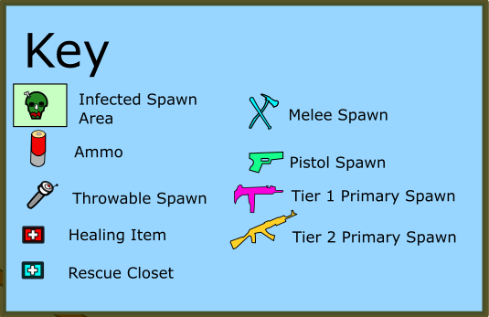
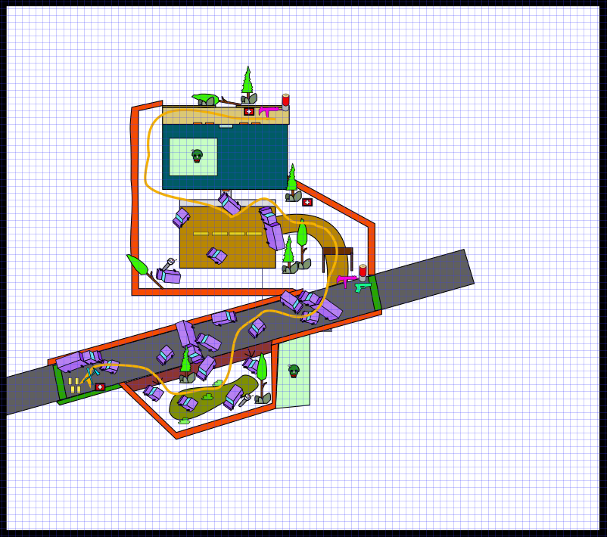
Section End
Back Porch
Parking Lot
Camp Entrance
Roadside Ditch
Welcome Building
Player Start
6
4
3
5
2
1
Figure 5: Section 1 Overview

Map Label | Event Description | Detail Information
1 | Players Collect Starting Supplies | Sitting on the hood of a car near the spawn are a collection of melee weapons and health items
2 | Players Fight The Hoard On Side of Road | With only their melee weapons players navigate the abandoned highway taking a short detour into a muddy ditch beside the road. Here zombies climb over hedges from outside the playable space to confront the players.
3 | Players Climb Over Cars & Trucks | In the players’ way is a large turned over semi-truck to be climbed over with the use of smaller vehicles near by
4 | Players Collect Tier 1 & Sidearms at Camp Entrance | At the edge of the accessible main road, sitting at the entrance to the camp are tier 1 weapons and pistols left over by long gone survivors.
5 | Players Must Go Around Welcome Building | With the front entrance to the welcome building blocked by crashed cars the players navigate through the parking lot before going around the side of the building in a tight straightaway between wall and shrubs. Zombies attack the player from ahead but also from above on the roof of the large welcome lodge
6 | Players Given Option to Change Weapons On Welcome Center Back Porch | At the edge of the back deck of the welcome building is another set of left over tier one weapons and ammo allowing players to try out another weapon for the next leg of the level

Bummer Camp Section 2 Detailed Breakdown



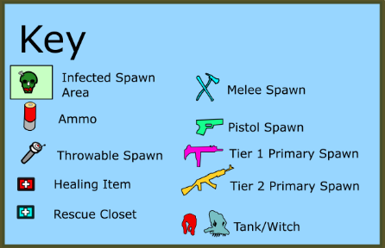
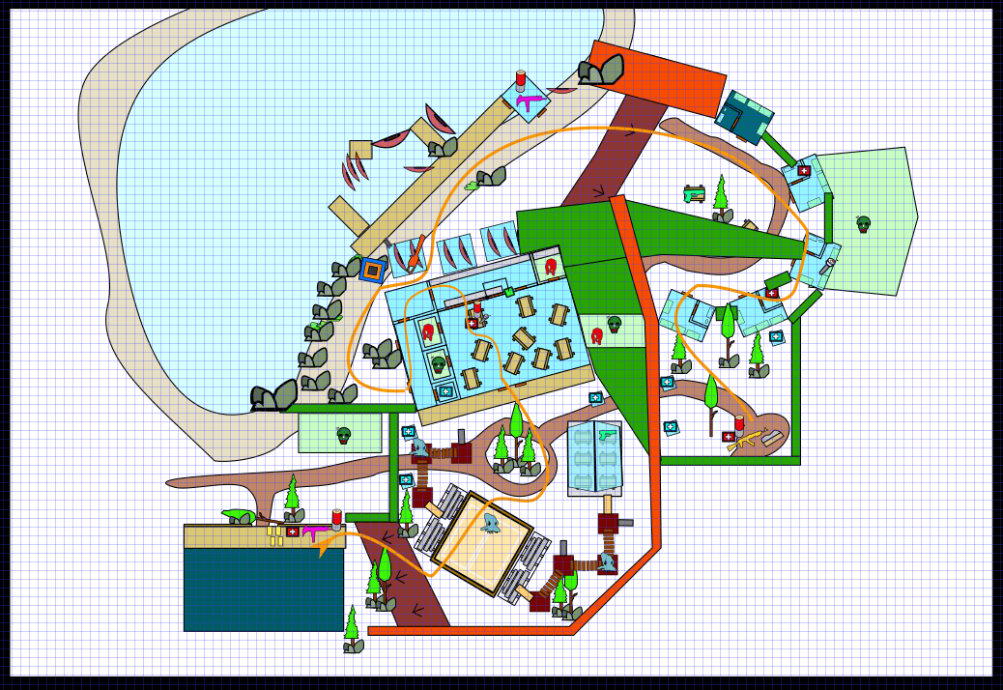
Ammo Upgrade

Special Weapon

Mess Hall
6
Fishing Interactions

4
2
Rockwall
Gazebo
Volleyball
Lakeside Docks
Cabins
Section End
Section Start
5
3
9
7
8
1
Figure 6: Section 2 Overview
Map Label | Event Description | Detail Information
1 | Players May Save Teammates | Heading off the deck the players discover a porta-potty serving as rescue closet allowing dead players to rejoin the team
2 | Players Avoid the Witch | Within the activity area players avoid the witch that can spawn in 1 of 3 places. Players are encouraged to approach the witch to grab an AK47 nearby. In this section are several fun physics interactables such as swings and tether balls.
3 | Player Enter Mess Hall | In the mess hall are numerous supplies scattered among overturned and misaligned picnic tables. The only way forward is through the kitchen window currently closed with a gate. The button nearby opens the gate but also alerts the hoard with its noise. Players defend their position waiting for the gate to the kitchen to open as zombies pour in from all sides.
4 | Players Fight the Tank | Once the panic event has subsided a tank busts into the mess hall from 1 of 3 locations. When the tank is killed the kitchen window gate opens faster allowing a quick exit.
5 | Players Run Beside Lake | After surviving the mess hall players can revive their dead team members before heading out to the lake edge. Here players navigate around boulders along the sand in addition to boats while fighting the hoard. Players can climb on top of the boat storage for a nice advantage. Here there are 2 fishing poles that can be activated by players. 1 grants a grenade launcher after dropping and lifting the lure. The second fishing pole has a defibrillator that needs to be reeled in by activating it 3 times
6 | Players May Change Weapons | At the dock house players have another opportunity to change out their primary weapon as well as get more ammo.
7 | Players Face Hoards of Climbing Zombies | Climbing over the accessible smaller cabins and inaccessible counselor cabin are many infected to be dispatched.
8 | Players Loot Cabins | In the small cabins players can find healing items as well as throwables. In the hands of a downed paratrooper hanging in a tree is a strong machine gun one player can grab by jumping on a nearby table
9 | Players Gather Tier 2 Weapons | Heading through a small space between 2 cabins players discover a stash of tier two weapons and ammo for the final section ahead.

Bummer Camp Section 3 Detailed Breakdown

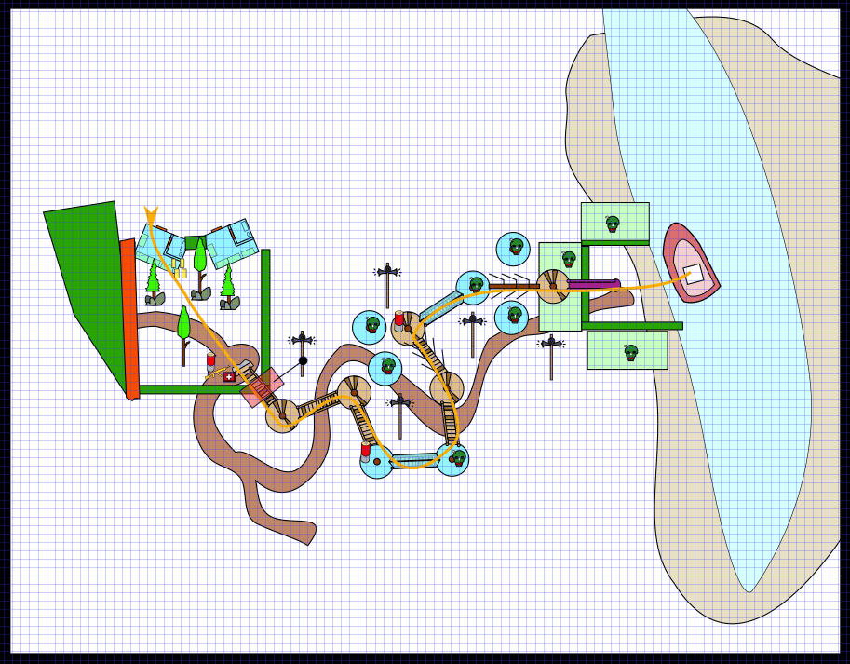
Section Start
Level End
Finale Trigger
Final Slide
1
Treehouse
Tree Course
Rockwall
6
5
4
3
2
7
Figure 7: Section 3 Overview
Map Label | Event Description | Detail Information
1 | Players Climb Rock Wall | The only way forward for players not blocked by bushes or trees is a large rock wall leading to a treetop obstacle course.
2 | Players Trigger Loudspeakers | When players reach the top of the rock wall the camp’s loudspeakers short circuit and turn on, blasting trumpets and music to signal a new day for the campers. This loud noise triggers an onslaught of zombies from ahead in the obstacles course.
3 | Players Cross Safe Bridges | Players cross several bridges with railings ensuring they don’t fall off as zombies pour towards them from ahead.
4 | Players Enter Treehouses | Players move from the uncovered platforms in the trees to small enclosed platforms connected by a covered bridge full of zombies
5 | Players Cross Unsafe Bridges | Now players cross a rope bridge without railings with players having to be careful about not falling off and having to be lifted by teammates
6 | Players Cross Very Unsafe Log | At the end of the course is a log serving as a tightrope that requires more precision to cross than any other part of the course.
7 | Players Ride Slide to Rescue | Attached to the final platform is a long slippery slide the players ride down to a final mad dash the boat waiting for them

Objective(s)
- Overcome the hordes of dead camp counselors to reach the rescue vehicle.

Hook(s)/Gameplay Highlights
- Strong BSP Theming
- Mid-Level Mess Hall Defense
- Treetop Gauntlet Event ending with Slide

Campaign Level

Context
The survivors’ car has finally run out gas. They have plans to rendezvous with a rescue boat but the only way forward is through an abandoned summer camp.

Aftermath
Following the daring treetop escape the survivors get on the rescue boat and head for calmer shores.

Development Schedule
Milestone | Date
LDD | 1/31
Blockmesh | 2/7
Whitebox | 2/21
Initial Gameplay | 3/13
Gameplay Complete | 4/3
Aesthetics | 4/17
RTM | 2/28

Key Theme References

Camp Entrance
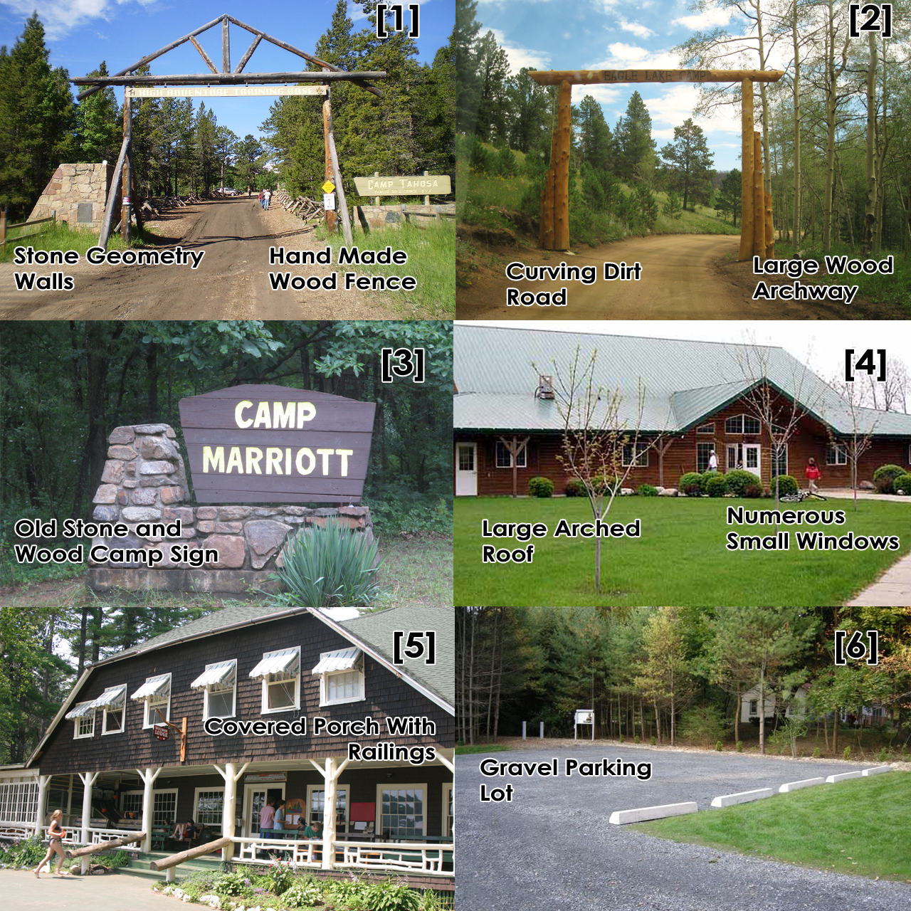
Figure 8: Camp Entrance Contact Sheet

Mess Hall

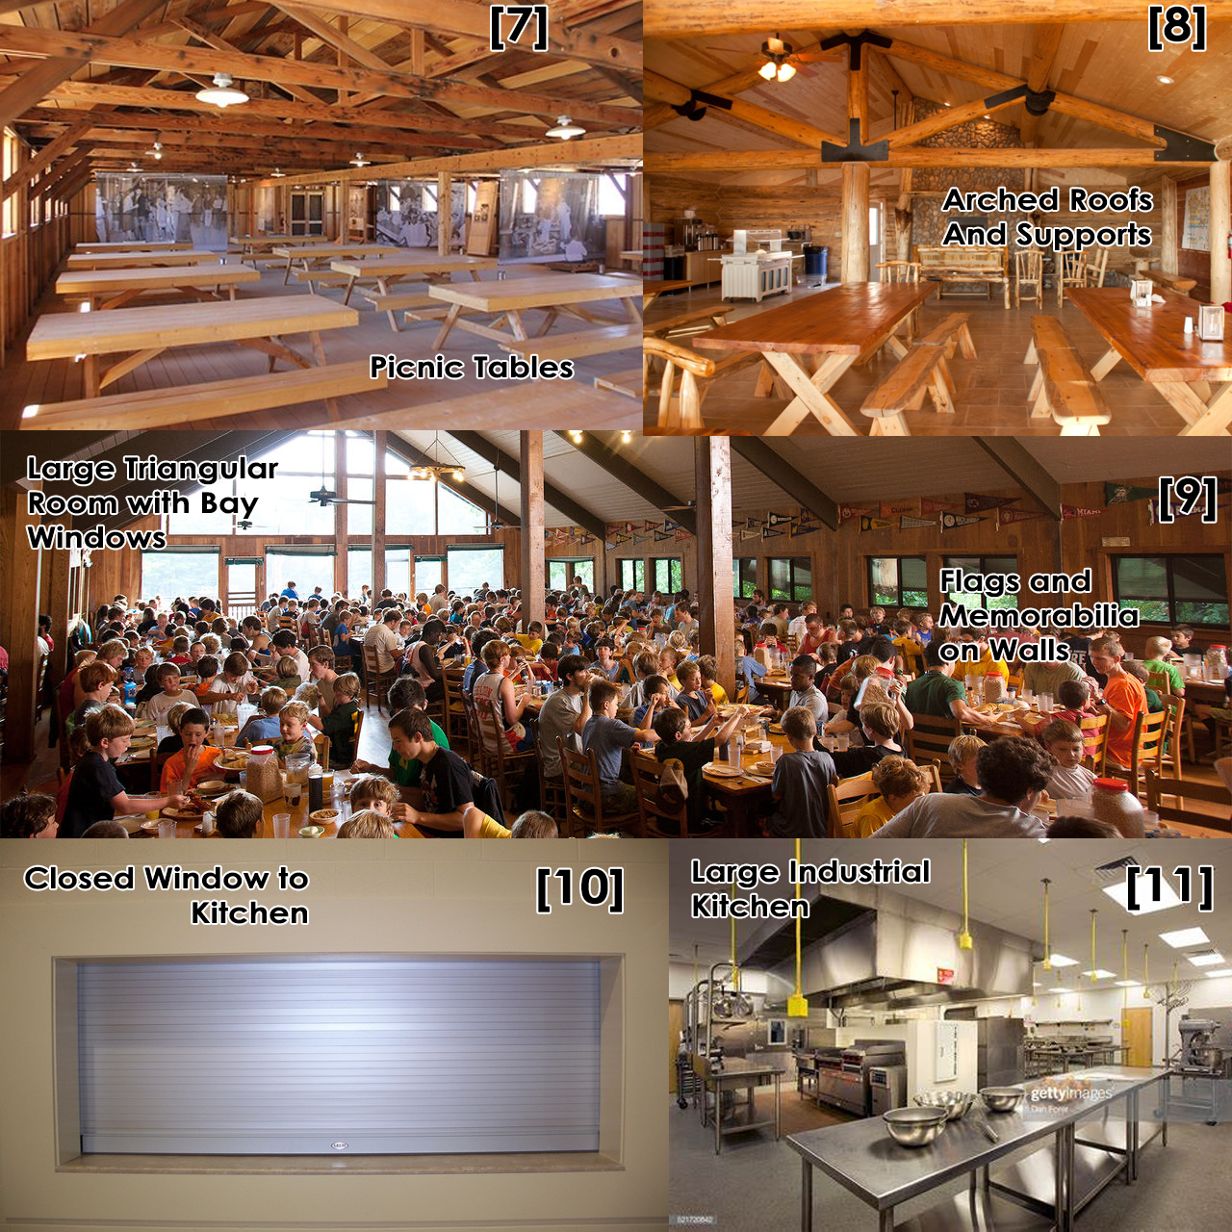
Figure 9: Mess Hall Contact Sheet

Lake
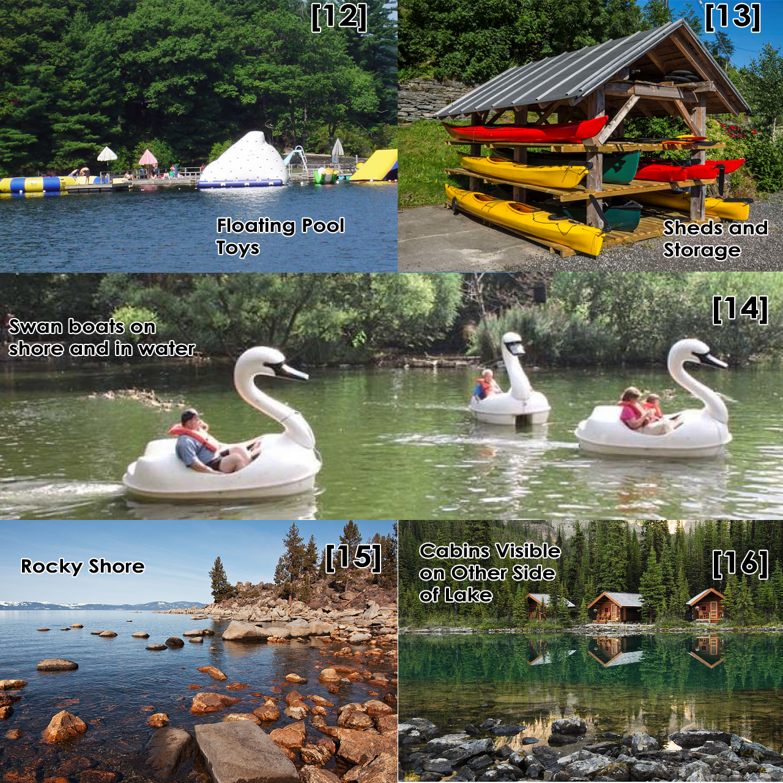
Figure 10: Lake Contact Sheet

Cabin
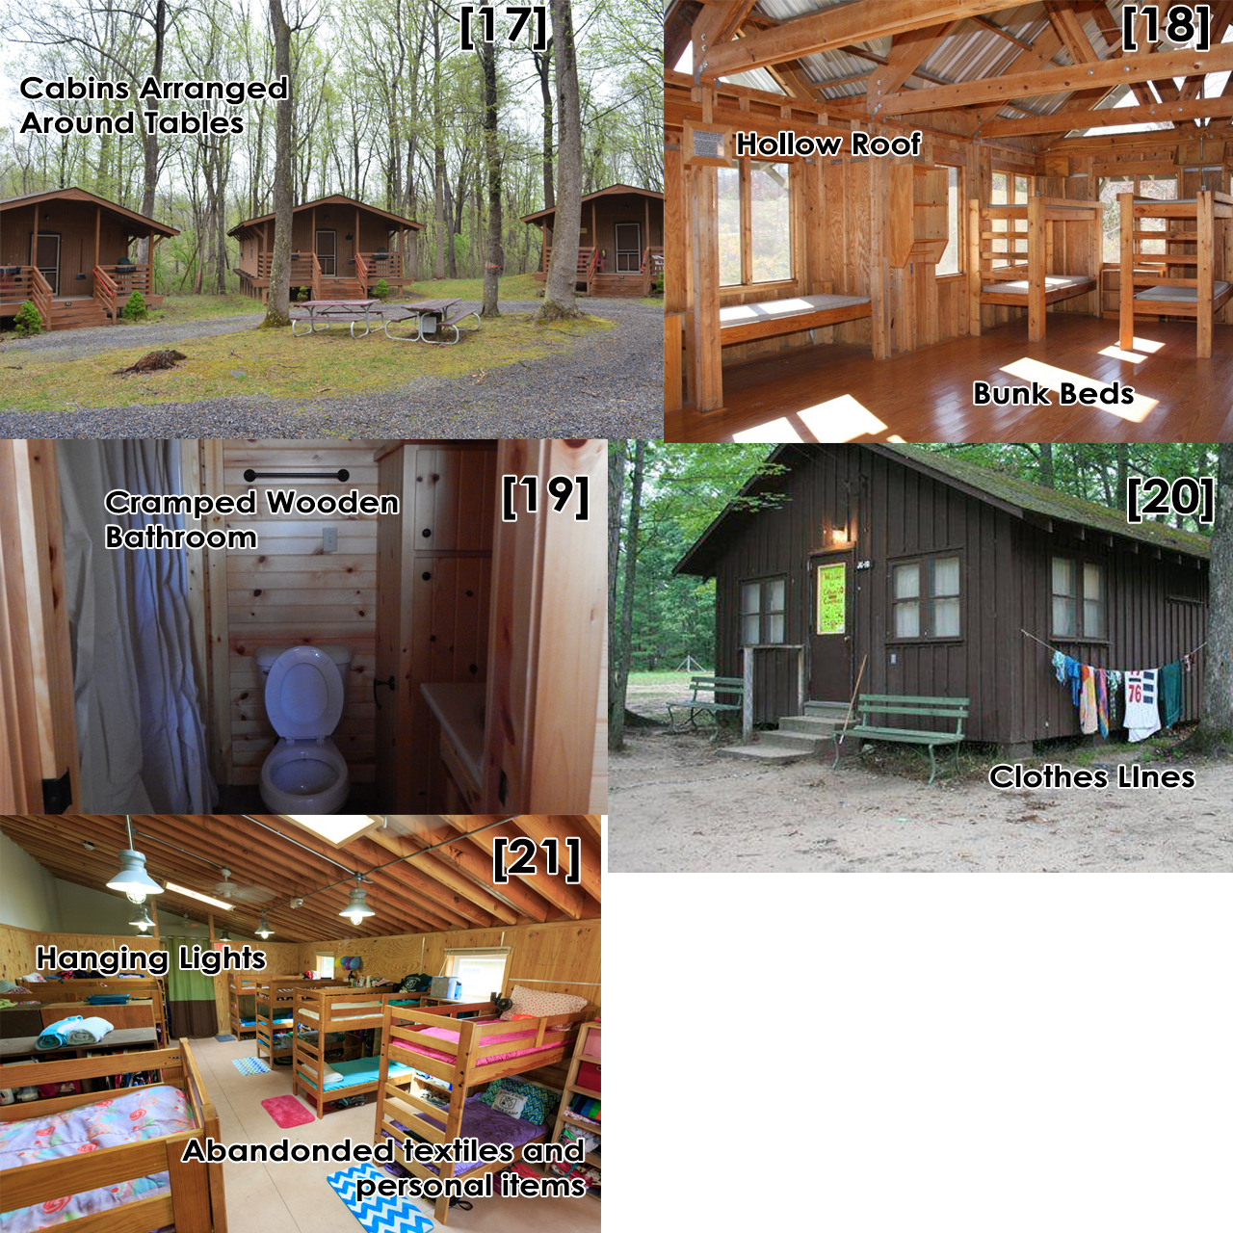
Figure 11: Cabin Contact Sheet

Treetop Obstacle Course

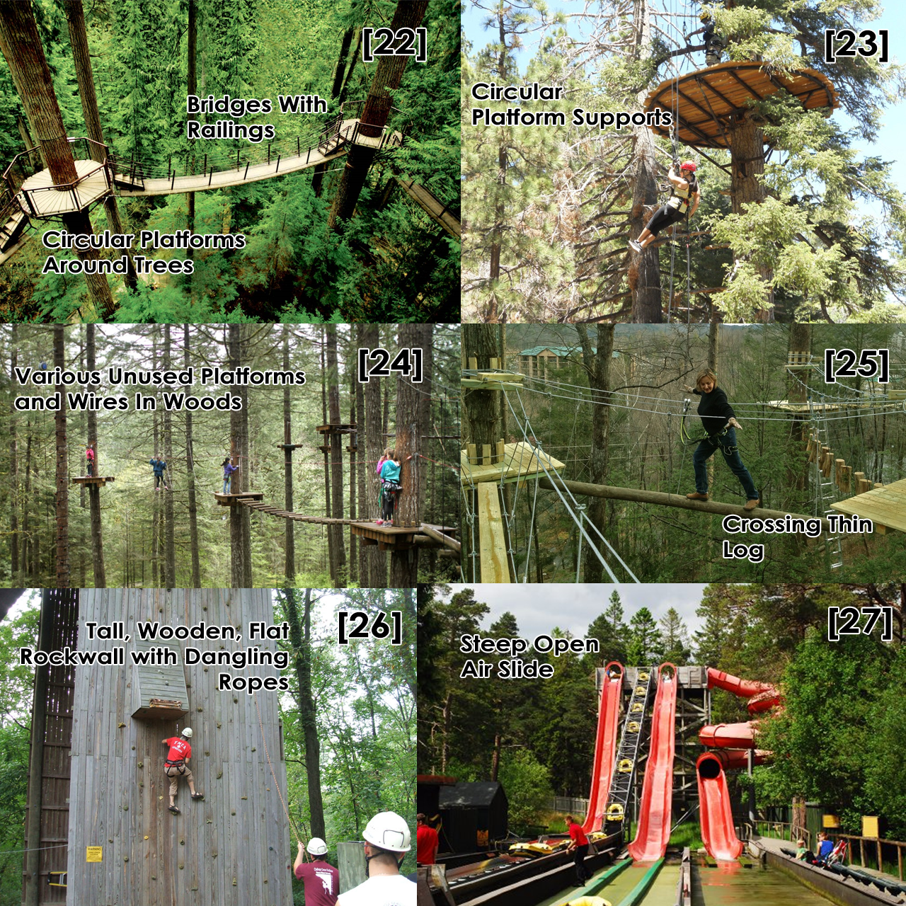
Figure 12: Obstacle Course Contact Sheet

Asset List
Area | Asset Type | Asset Name | In Engine Name
Camp Wide | Static Prop | Trees | - B_tree_pine04  - Mall_tree_large01  - Oak_tree01  - Old_tree01  - Tree_city01  - Tree_dry02  - Tree_pineo4_tall  - Tree_pine04_tallcluster  - Tree_pine_card_cluster  - Urban_tree_giant01  - Coldstream_cedar  - Coldstream_oak  - Colstream_cedar_trunk
Camp Wide | Static Prop | Boulders | - Rock_cliff01e-02e  - Rock_coast01a-02h  - Forestrock_closter01-03  - River_Rocks_1-2  - River_rocks_large_1  - Rock_moss01-05
Camp Wide | Static Prop | Small Shrubs | - Oak_shrub  - Shrub_small  - Swamp_shrubwall_256a-b  - Swampshrubwall_512 (all varieties)  - Swamp_shrubwall_block(varieties)
Camp Wide | Static Prop | Knocked Over Trees | - Fallentree01  - Fallentree_dry01-02  - sWamp_fallentree01  - swamp_fallentree_dry01  - tree_trunk_chunk01-06  - tree_trunk_fallen
Camp Wide | Static Prop | Benches | - bench_wood  - bench_indoor001a
Camp Wide | Static Prop | Picnic Tables | - bench002  - table_picnic
Camp Wide | Static Prop | Trash Cans | - garbage_can  - garbage_can001
Camp Wide | Static Prop | Porta-Potties | - outhouse001-002
Camp Wide | Static Prop | Fire Pit | - firepit_campground  - grill_campground
Camp Wide | Static Prop | Wooden Logs | - logpile2  - riverlogs
Road | Static Prop | Vehicles | - ambulance  - bus01  - car001a-0005b  - cara_69sedan  - delivaryvan  - flatnose_truck  - pickup_truck (all variants)  - semi_trailer  - trailer_small01
Road | Static Prop | Guard Rails | - fence01_256  - concrete_barricade02
Road | Static Prop | Cones | - orange_cone01
Road | Static Prop | Parking Lot Divider | - concreteblock01_128  - traffic_baricade_01
Road | Static Prop | Fence | - barricade01_128
Mess Hall Area | Static Prop | Bleacher | - stadium_bench5
Mess Hall Area | Static Prop | Kitchen Equipment
Mess Hall Area | Static Prop | Trophy Cases, Knick Knacks, Photographs, Paintings | - refrigerator03  - refrigerator_industrial01  - sink_industrial01  - stove03_industrial  - stove04_industrial  - industrial_table01
Mess Hall Area | Static Prop | Piles of Food Trash | - food_pile01-03  - trashcluster01a  - garbage_pile01-03  - garbage_pile_corner01-02
Mess Hall Area | Static Prop | Arts and Crafts Supplies | - spraypaintcan01a  - paintcan001a-001b  - paper_tray  - newspaper001a
Lake Area | Static Prop | Swan Boats | - swan_boat
Lake Area | Static Prop | Dock Kit | - dock_01_polecluster01d_256  - dock02_a  - marina_dock  - canal_dock02a  - cleat_small_01-02
Lake Area | Static Prop | Small Boat | - boat001a  - boat002
Cabin Area | Static Prop | Clothing, Luggage | - luggage1-luggage4  - luggage_pile1  - clothing_pile1-5  - clothing_jeans  - clothing_tshirts  - clothing_shirts_draping01
Cabin Area | Static Prop | Bathroom Equipment | - toilet_a-d  - toiletpaperdispenser_residendial  - toiletpaperroll  - soap_dispenser  - bathroom_vanity01  - toothbrushset01  - bathtub01  - showercurtain01  - hotel_bathroom_showerhead001  - hotel_bathroom_showerrod001
Cabin Area | Static Prop | Dumpsters | - trashdumpster01a-02
Obstacle Course Area | Static Prop | Wooden Bridge | - rope_bridge
Obstacle Course Area | Static Prop | Helmets, Harnesses, Rope | - backpack  - clipboard01
Obstacle Course Area | Dynamic Prop | Boat | - boat_rescue_tug_sunshine
Road | Custom Func Detail | Welcome Signs | N/A
Road | Custom Func Detail | Welcome Building | N/A
Road | Custom Func Detail | Back Porch & Railings | N/A
Mess Hall Area | Custom Func Detail | Volleyball Nets | N/A
Mess Hall Area | Custom Func Detail | Gazebo | N/A
Mess Hall Area | Custom Func Detail | Mess Hall Supports and Architecture | N/A
Lake Area | Custom Func Detail | Boat Storage Area | N/A
Cabin Area | Custom Func Detail | Cabin Exteriors and Interiors | N/A
Cabin Area | Custom Func Detail | Bunk Beds | N/A
Obstacle Course Area | Custom Func Detail | Wooden Bridges | N/A
Obstacle Course Area | Custom Func Detail | Treetop Platforms | N/A
Obstacle Course Area | Custom Func Detail | Treehouses | N/A
Obstacle Course Area | Custom Func Detail | Slide | N/A

Custom Assets
Area | Asset Type | Asset Name | In Engine Name
Camp Wide | Material | Camp Logo | - custom/camplogo
Mess Hall Area | Material | Volleyball Net | - custom/netmaterial
Road Area | Material | Level Logo | - custom/bummercamplogo
Road Area | Model Skin | Camp Bus | - church_bus_01
Camp Wide | Model Skin | Camp Banner | - fairgrounds_banner02
Camp Wide | Weapon Skin | Nerf Shotgun | - weapon_pumpshotgun_spawn
Camp Wide | Weapon Skin | Nerf SMG | - weapon_smg_spawn

References
- https://farm3.staticflickr.com/2612/3682866284_ebb046a342_z.jpg
- https://nouvellevieinme.files.wordpress.com/2013/08/img_7563.jpg
- http://bethesdatroop233.org/wp-content/uploads/2017/12/IMG_0269.jpg
- http://www.ihms.mb.ca/News%20&%20Events/News%20and%20Events%202008-09/Gr%205%20and%206%20Camp/main%20building%201
- https://cms.bunac.org/media/images/_SummerCamp/building%20lodge.JPG
- http://www.duboishomesite.org/Images/ParkingLot08.jpg
- https://c2.staticflickr.com/8/7139/7521101070_4c27a4b72b.jpg
- https://cq5publish.ou.edu/content/dam/mcee/geology/images/Slide_show/Field%20Camp/sgg_fieldcamp2011_h.jpg
- https://lindadhummel.files.wordpress.com/2015/06/camp-dining-hall-action.jpg
- http://www.bardstownoverheaddoors.com/uploads/3/5/4/5/3545853/5010772_orig.jpg
- https://www.bing.com/images/search?view=detailV2&id=9F5E2BF191792C50A6DDC170BD2D4D33C9596E3A&thid=OIP.__S7TzbpEkL34Xlm4vvt2gHaE7&mediaurl=https%3A%2F%2Fmedia.gettyimages.com%2Fphotos%2Fhigh-school-cafeteria-kitchen-picture-id521720842&exph=682&expw=1024&q=high+school+cafeteria+kitchen&selectedindex=0&ajaxhist=0&vt=0&eim=1,2,6
- https://bergenmama.com/images/uploads/bergenmama_summer_camps_with_lakes_near_bergen_county_nj_main.jpg
- https://www.homestratosphere.com/wp-content/uploads/2018/10/Outdoor-kayak-storage-shed-oct12.jpg
- https://s.hdnux.com/photos/73/62/47/15673828/5/920x920.jpg
- https://c2.staticflickr.com/6/5171/5487952414_e2e2846e61_b.jpg
- https://farm7.staticflickr.com/6076/6095482736_8e1951c30e_z.jpg
- http://svite-league-apps-content.s3.amazonaws.com/1712/2100/9f7079bd-925d-4d4b-997f-14e1ad606295.jpeg
- https://www.ymcacampocoee.org/sites/default/files/2017-12/Cabin%20Photos%20008.jpg
- https://akroncantonjellystone.com/wp-content/uploads/2015/05/Cabin1-bath.jpg
- https://media.glassdoor.com/l/90/26/67/2d/one-of-the-cabins-the-campers-live-in-with-the-counselors.jpg
- https://www.bebercamp.com/wp-content/uploads/2016/05/girls-bunks.jpg
- https://graitlin.files.wordpress.com/2013/07/treetops-large-5.jpg
- http://www.ecovillagecomo.it/images/ae/tree/07.jpg
- https://tree2treeadventurepark.com/images/slides/benefits-of-aerial/Benefits%20of%20Aerial%20Obstacle%20Courses.jpg
- http://www.placestoseeintennessee.com/wp-content/uploads/2014/04/Log-walk.jpg
- http://www.wiu.edu/coehs/rpta/horn_field_campus/images/tower2.jpg
- https://media-cdn.tripadvisor.com/media/photo-s/0b/d7/86/5b/water-slides.jpg

